Dear Dongwook lee

I’m doing some computational investigation on the electrical explosion of thin metallic wire in vacuum with the FLASH code. I carry out the simulation based on the magnetized Noh Z-pinch. The initial conditions have been modified according to the electrical explosion of metal wires, i.e., a metal wire of 10μm in diameter embedded in a vacuum (the density for aluminum wire is 2700kg/m3, the density of vacuum is 10-4 kg/m3). The initial temperature is 300K and the velocity is zero.

I applied the USM scheme in cartesian coordinate. However, the simulation will abort within three steps, because the dt is not positive. I have tried all the provided RiemannSolver. The distribution of density in the initial stage is set as follows

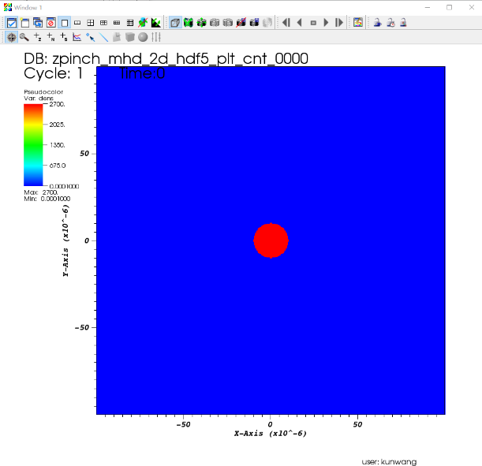

Fig.1 the density distribution in the initial stage

However, the velocity and temperature will increase to a very big values at the interface of metal wire and vacuum in discrete points, which are obviously incorrect, as shown in Fig.2.

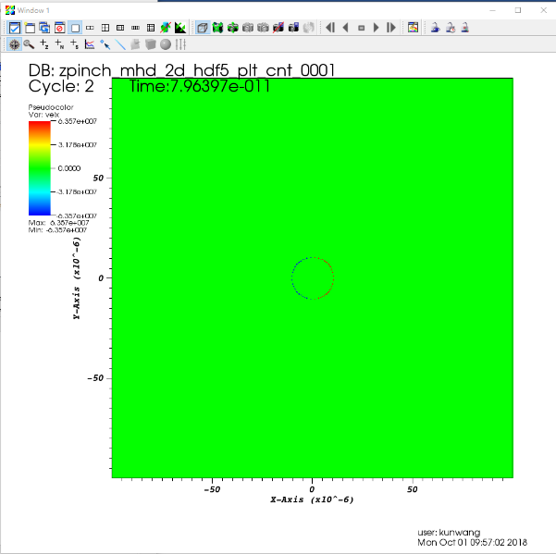

Fig. 2 the velocity distribution at 1 step

If I reduce the interpolation order from 2 to 1, i.e., from MH to FOG, the simulation will go smoothly. I wonder if there is something wrong with the interpolation modules. Do you have any suggestions? Thank you very much.

Best wishes!

Wang Kun